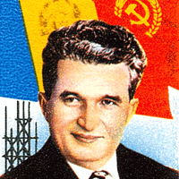

[https://www.google.com/url?sa=i HYPERLINK "https://www.google.com/url?sa=i&url=https%3A%2F%2Fpicryl.com%2Fmedia%2Fnicolae-ceausescu-7b8ab5&psig=AOvVaw2x4PYYdQTVajJdudjDB0fI&ust=1740853374437000&source=images&cd=vfe&opi=89978449&ved=0CBkQjhxqFwoTCNiXq6r-5osDFQAAAAAdAAAAABAE"& HYPERLINK "https://www.google.com/url?sa=i&url=https%3A%2F%2Fpicryl.com%2Fmedia%2Fnicolae-ceausescu-7b8ab5&psig=AOvVaw2x4PYYdQTVajJdudjDB0fI&ust=1740853374437000&source=images&cd=vfe&opi=89978449&ved=0CBkQjhxqFwoTCNiXq6r-5osDFQAAAAAdAAAAABAE"url=https%3A%2F%2Fpicryl.com%2Fmedia%2Fnicolae-ceausescu-7b8ab5 HYPERLINK "https://www.google.com/url?sa=i&url=https%3A%2F%2Fpicryl.com%2Fmedia%2Fnicolae-ceausescu-7b8ab5&psig=AOvVaw2x4PYYdQTVajJdudjDB0fI&ust=1740853374437000&source=images&cd=vfe&opi=89978449&ved=0CBkQjhxqFwoTCNiXq6r-5osDFQAAAAAdAAAAABAE"& HYPERLINK "https://www.google.com/url?sa=i&url=https%3A%2F%2Fpicryl.com%2Fmedia%2Fnicolae-ceausescu-7b8ab5&psig=AOvVaw2x4PYYdQTVajJdudjDB0fI&ust=1740853374437000&source=images&cd=vfe&opi=89978449&ved=0CBkQjhxqFwoTCNiXq6r-5osDFQAAAAAdAAAAABAE"psig=AOvVaw2x4PYYdQTVajJdudjDB0fI HYPERLINK "https://www.google.com/url?sa=i&url=https%3A%2F%2Fpicryl.com%2Fmedia%2Fnicolae-ceausescu-7b8ab5&psig=AOvVaw2x4PYYdQTVajJdudjDB0fI&ust=1740853374437000&source=images&cd=vfe&opi=89978449&ved=0CBkQjhxqFwoTCNiXq6r-5osDFQAAAAAdAAAAABAE"& HYPERLINK "https://www.google.com/url?sa=i&url=https%3A%2F%2Fpicryl.com%2Fmedia%2Fnicolae-ceausescu-7b8ab5&psig=AOvVaw2x4PYYdQTVajJdudjDB0fI&ust=1740853374437000&source=images&cd=vfe&opi=89978449&ved=0CBkQjhxqFwoTCNiXq6r-5osDFQAAAAAdAAAAABAE"ust=1740853374437000 HYPERLINK "https://www.google.com/url?sa=i&url=https%3A%2F%2Fpicryl.com%2Fmedia%2Fnicolae-ceausescu-7b8ab5&psig=AOvVaw2x4PYYdQTVajJdudjDB0fI&ust=1740853374437000&source=images&cd=vfe&opi=89978449&ved=0CBkQjhxqFwoTCNiXq6r-5osDFQAAAAAdAAAAABAE"& HYPERLINK "https://www.google.com/url?sa=i&url=https%3A%2F%2Fpicryl.com%2Fmedia%2Fnicolae-ceausescu-7b8ab5&psig=AOvVaw2x4PYYdQTVajJdudjDB0fI&ust=1740853374437000&source=images&cd=vfe&opi=89978449&ved=0CBkQjhxqFwoTCNiXq6r-5osDFQAAAAAdAAAAABAE"source=images HYPERLINK "https://www.google.com/url?sa=i&url=https%3A%2F%2Fpicryl.com%2Fmedia%2Fnicolae-ceausescu-7b8ab5&psig=AOvVaw2x4PYYdQTVajJdudjDB0fI&ust=1740853374437000&source=images&cd=vfe&opi=89978449&ved=0CBkQjhxqFwoTCNiXq6r-5osDFQAAAAAdAAAAABAE"& HYPERLINK "https://www.google.com/url?sa=i&url=https%3A%2F%2Fpicryl.com%2Fmedia%2Fnicolae-ceausescu-7b8ab5&psig=AOvVaw2x4PYYdQTVajJdudjDB0fI&ust=1740853374437000&source=images&cd=vfe&opi=89978449&ved=0CBkQjhxqFwoTCNiXq6r-5osDFQAAAAAdAAAAABAE"cd=vfe HYPERLINK "https://www.google.com/url?sa=i&url=https%3A%2F%2Fpicryl.com%2Fmedia%2Fnicolae-ceausescu-7b8ab5&psig=AOvVaw2x4PYYdQTVajJdudjDB0fI&ust=1740853374437000&source=images&cd=vfe&opi=89978449&ved=0CBkQjhxqFwoTCNiXq6r-5osDFQAAAAAdAAAAABAE"& HYPERLINK "https://www.google.com/url?sa=i&url=https%3A%2F%2Fpicryl.com%2Fmedia%2Fnicolae-ceausescu-7b8ab5&psig=AOvVaw2x4PYYdQTVajJdudjDB0fI&ust=1740853374437000&source=images&cd=vfe&opi=89978449&ved=0CBkQjhxqFwoTCNiXq6r-5osDFQAAAAAdAAAAABAE"opi=89978449 HYPERLINK "https://www.google.com/url?sa=i&url=https%3A%2F%2Fpicryl.com%2Fmedia%2Fnicolae-ceausescu-7b8ab5&psig=AOvVaw2x4PYYdQTVajJdudjDB0fI&ust=1740853374437000&source=images&cd=vfe&opi=89978449&ved=0CBkQjhxqFwoTCNiXq6r-5osDFQAAAAAdAAAAABAE"& HYPERLINK "https://www.google.com/url?sa=i&url=https%3A%2F%2Fpicryl.com%2Fmedia%2Fnicolae-ceausescu-7b8ab5&psig=AOvVaw2x4PYYdQTVajJdudjDB0fI&ust=1740853374437000&source=images&cd=vfe&opi=89978449&ved=0CBkQjhxqFwoTCNiXq6r-5osDFQAAAAAdAAAAABAE"ved=0CBkQjhxqFwoTCNiXq6r-5osDFQAAAAAdAAAAABAE](https://www.google.com/url?sa=i&url=https%3A%2F%2Fpicryl.com%2Fmedia%2Fnicolae-ceausescu-7b8ab5&psig=AOvVaw2x4PYYdQTVajJdudjDB0fI&ust=1740853374437000&source=images&cd=vfe&opi=89978449&ved=0CBkQjhxqFwoTCNiXq6r-5osDFQAAAAAdAAAAABAE)

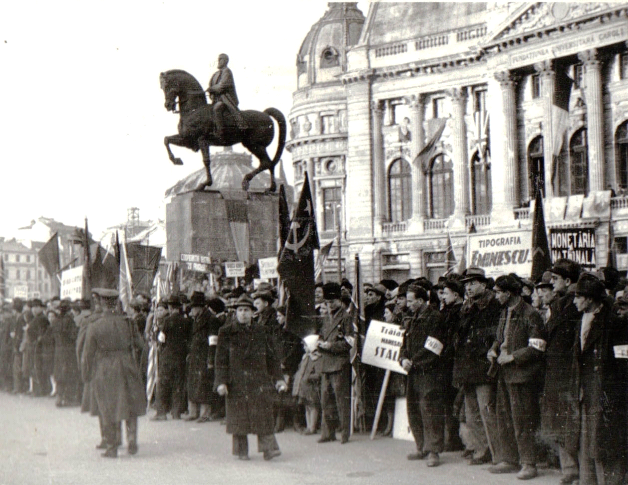

[https://www.google.com/url?sa=i HYPERLINK "https://www.google.com/url?sa=i&url=https%3A%2F%2Fcommons.wikimedia.org%2Fwiki%2FFile%3AArdeal_1945_Buc.jpg&psig=AOvVaw0PC52uR7lKqx4TCjnlXrZo&ust=1740853983998000&source=images&cd=vfe&opi=89978449&ved=0CBkQjhxqFwoTCJCWzdOA54sDFQAAAAAdAAAAABBQ"& HYPERLINK "https://www.google.com/url?sa=i&url=https%3A%2F%2Fcommons.wikimedia.org%2Fwiki%2FFile%3AArdeal_1945_Buc.jpg&psig=AOvVaw0PC52uR7lKqx4TCjnlXrZo&ust=1740853983998000&source=images&cd=vfe&opi=89978449&ved=0CBkQjhxqFwoTCJCWzdOA54sDFQAAAAAdAAAAABBQ"url=https%3A%2F%2Fcommons.wikimedia.org%2Fwiki%2FFile%3AArdeal_1945_Buc.jpg HYPERLINK "https://www.google.com/url?sa=i&url=https%3A%2F%2Fcommons.wikimedia.org%2Fwiki%2FFile%3AArdeal_1945_Buc.jpg&psig=AOvVaw0PC52uR7lKqx4TCjnlXrZo&ust=1740853983998000&source=images&cd=vfe&opi=89978449&ved=0CBkQjhxqFwoTCJCWzdOA54sDFQAAAAAdAAAAABBQ"& HYPERLINK "https://www.google.com/url?sa=i&url=https%3A%2F%2Fcommons.wikimedia.org%2Fwiki%2FFile%3AArdeal_1945_Buc.jpg&psig=AOvVaw0PC52uR7lKqx4TCjnlXrZo&ust=1740853983998000&source=images&cd=vfe&opi=89978449&ved=0CBkQjhxqFwoTCJCWzdOA54sDFQAAAAAdAAAAABBQ"psig=AOvVaw0PC52uR7lKqx4TCjnlXrZo HYPERLINK "https://www.google.com/url?sa=i&url=https%3A%2F%2Fcommons.wikimedia.org%2Fwiki%2FFile%3AArdeal_1945_Buc.jpg&psig=AOvVaw0PC52uR7lKqx4TCjnlXrZo&ust=1740853983998000&source=images&cd=vfe&opi=89978449&ved=0CBkQjhxqFwoTCJCWzdOA54sDFQAAAAAdAAAAABBQ"& HYPERLINK "https://www.google.com/url?sa=i&url=https%3A%2F%2Fcommons.wikimedia.org%2Fwiki%2FFile%3AArdeal_1945_Buc.jpg&psig=AOvVaw0PC52uR7lKqx4TCjnlXrZo&ust=1740853983998000&source=images&cd=vfe&opi=89978449&ved=0CBkQjhxqFwoTCJCWzdOA54sDFQAAAAAdAAAAABBQ"ust=1740853983998000 HYPERLINK "https://www.google.com/url?sa=i&url=https%3A%2F%2Fcommons.wikimedia.org%2Fwiki%2FFile%3AArdeal_1945_Buc.jpg&psig=AOvVaw0PC52uR7lKqx4TCjnlXrZo&ust=1740853983998000&source=images&cd=vfe&opi=89978449&ved=0CBkQjhxqFwoTCJCWzdOA54sDFQAAAAAdAAAAABBQ"& HYPERLINK "https://www.google.com/url?sa=i&url=https%3A%2F%2Fcommons.wikimedia.org%2Fwiki%2FFile%3AArdeal_1945_Buc.jpg&psig=AOvVaw0PC52uR7lKqx4TCjnlXrZo&ust=1740853983998000&source=images&cd=vfe&opi=89978449&ved=0CBkQjhxqFwoTCJCWzdOA54sDFQAAAAAdAAAAABBQ"source=images HYPERLINK "https://www.google.com/url?sa=i&url=https%3A%2F%2Fcommons.wikimedia.org%2Fwiki%2FFile%3AArdeal_1945_Buc.jpg&psig=AOvVaw0PC52uR7lKqx4TCjnlXrZo&ust=1740853983998000&source=images&cd=vfe&opi=89978449&ved=0CBkQjhxqFwoTCJCWzdOA54sDFQAAAAAdAAAAABBQ"& HYPERLINK "https://www.google.com/url?sa=i&url=https%3A%2F%2Fcommons.wikimedia.org%2Fwiki%2FFile%3AArdeal_1945_Buc.jpg&psig=AOvVaw0PC52uR7lKqx4TCjnlXrZo&ust=1740853983998000&source=images&cd=vfe&opi=89978449&ved=0CBkQjhxqFwoTCJCWzdOA54sDFQAAAAAdAAAAABBQ"cd=vfe HYPERLINK "https://www.google.com/url?sa=i&url=https%3A%2F%2Fcommons.wikimedia.org%2Fwiki%2FFile%3AArdeal_1945_Buc.jpg&psig=AOvVaw0PC52uR7lKqx4TCjnlXrZo&ust=1740853983998000&source=images&cd=vfe&opi=89978449&ved=0CBkQjhxqFwoTCJCWzdOA54sDFQAAAAAdAAAAABBQ"& HYPERLINK "https://www.google.com/url?sa=i&url=https%3A%2F%2Fcommons.wikimedia.org%2Fwiki%2FFile%3AArdeal_1945_Buc.jpg&psig=AOvVaw0PC52uR7lKqx4TCjnlXrZo&ust=1740853983998000&source=images&cd=vfe&opi=89978449&ved=0CBkQjhxqFwoTCJCWzdOA54sDFQAAAAAdAAAAABBQ"opi=89978449 HYPERLINK "https://www.google.com/url?sa=i&url=https%3A%2F%2Fcommons.wikimedia.org%2Fwiki%2FFile%3AArdeal_1945_Buc.jpg&psig=AOvVaw0PC52uR7lKqx4TCjnlXrZo&ust=1740853983998000&source=images&cd=vfe&opi=89978449&ved=0CBkQjhxqFwoTCJCWzdOA54sDFQAAAAAdAAAAABBQ"& HYPERLINK "https://www.google.com/url?sa=i&url=https%3A%2F%2Fcommons.wikimedia.org%2Fwiki%2FFile%3AArdeal_1945_Buc.jpg&psig=AOvVaw0PC52uR7lKqx4TCjnlXrZo&ust=1740853983998000&source=images&cd=vfe&opi=89978449&ved=0CBkQjhxqFwoTCJCWzdOA54sDFQAAAAAdAAAAABBQ"ved=0CBkQjhxqFwoTCJCWzdOA54sDFQAAAAAdAAAAABBQ](https://www.google.com/url?sa=i&url=https%3A%2F%2Fcommons.wikimedia.org%2Fwiki%2FFile%3AArdeal_1945_Buc.jpg&psig=AOvVaw0PC52uR7lKqx4TCjnlXrZo&ust=1740853983998000&source=images&cd=vfe&opi=89978449&ved=0CBkQjhxqFwoTCJCWzdOA54sDFQAAAAAdAAAAABBQ)

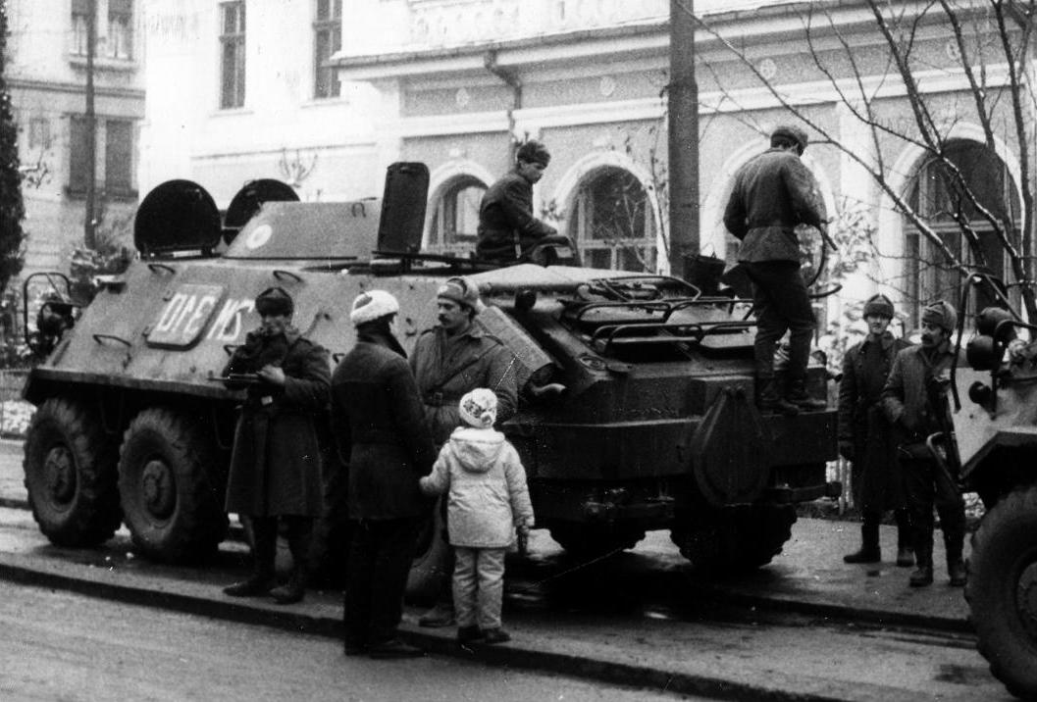

<https://commons.wikimedia.org/wiki/File:Rumanian_Revolution.jpg>

[**https://commons.wikimedia.org/wiki/File:1989_December_16._sug%C3%A1r%C3%BAt_%C3%A9s_a_Tudor_Vladimirescu_%C3%BAt_keresztez%C5%91d%C3%A9se._Fortepan_31892.jpg**](https://commons.wikimedia.org/wiki/File:1989_December_16._sug%C3%A1r%C3%BAt_%C3%A9s_a_Tudor_Vladimirescu_%C3%BAt_keresztez%C5%91d%C3%A9se._Fortepan_31892.jpg)

**Citation for all the pictures in the Timisoara folder:**

**Lucaciu, A., Duma, C., Milin, M., & Percec, D. (2019). *Timişoara la revoluţie = Timişoara during the revolution*. Brumar.**



[**https://commons.wikimedia.org/wiki/File:Romania_flag.jpg**](https://commons.wikimedia.org/wiki/File:Romania_flag.jpg)

[**https://commons.wikimedia.org/wiki/File:Flag_of_the_United_Kingdom_%281-1%29.svg**](https://commons.wikimedia.org/wiki/File:Flag_of_the_United_Kingdom_%281-1%29.svg)